Why is being barefoot healthier for my horse?
Your horses' feet are actually an integral part of his circulatory system. To help with the visual, the horse in the thermograph image below has three bare feet and one horseshoe on. The red indicates active blood circulation, and blue indicates severely limited circulation.
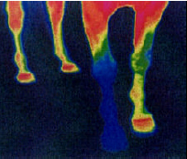

"The horse has five hearts; one in his chest, and one in each foot."

If we were to look at a thermograph image of a horse in motion, we would see the whole hoof flush with circulation as the hoof wall flexes to create a vacuum that "sucks" the blood into the bottom of the foot, drenching the vital internal structures of the hoof with nourishment. Unlike a dog or a human whose muscles "squeeze" the blood back up the leg, a horse does not have any muscles in the lower limbs, and so must rely on this critical blood pumping action the hoof creates in order to return blood back up the limb. The horseshoe forces the naturally flexible hoof capsule into an immobile, concrete position which immediately slows the blood flow into the hoof and leg, effectively shutting down four of the five blood-pumping centers in your horse's body.

